- \Operation\Strip transfer, unit C\Settings
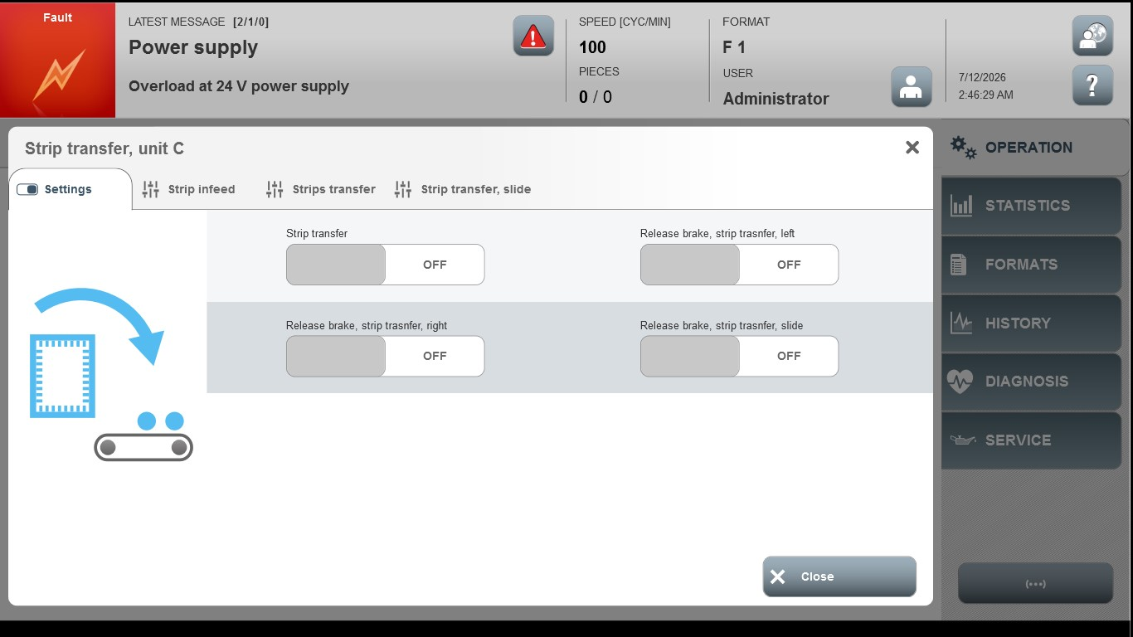

Acceptance criterion | Limits | Pass / Fail: Dev-No. | Date | Initials
Screen matches screenshot | N / A

